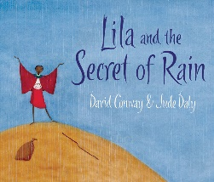
Date: Name:
LO: To answer comprehension questions about a text.
- Why do Lila and all the other villagers stay in their houses at the beginning of the story?
______________________________________________________
______________________________________________________
- What did Lila overhear her mama say?
______________________________________________________
______________________________________________________
- Who told Lila’s grandfather the secret of rain. What was the secret?
______________________________________________________
______________________________________________________
Inference
Why do you think the sky remained blue when Lila first spoke to it? What eventually made it rain?
______________________________________________________
______________________________________________________
______________________________________________________
The author describes the sky as ‘crying’. Why did the author choose this adjective?
________________________________________________________________________________________________________________________________________________________________________________________________________________________

