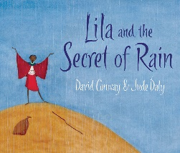
Date: Name:
LO: I can answer comprehension questions about a text.
- Where does Lila live?
______________________________________________________
______________________________________________________
- What 3 things was it too hot to do?
______________________________________________________
______________________________________________________
- What did Lila do when she first reached the top of the mountain?
______________________________________________________
______________________________________________________
- Why did the clouds get darker?
______________________________________________________
______________________________________________________
Inference
How do you think Lila felt when the rains did not come? Why do you think this?
______________________________________________________
______________________________________________________
______________________________________________________
______________________________________________________

