Learning Project WEEK 3 - Food
Below are a number of tasks for you to choose from this week. General resources and messages will also be posted on our class page. Some of these activities are the same or similar to previous weeks, this helps children consolidate their understanding but it’s also great to repeat activities they have enjoyed.
Remember you can go wherever the muse takes you with these activities!
Weekly Maths Tasks (Aim to do 1 per day) | Weekly Reading Tasks (Aim to do 1 per day)
- Watch a Numberblocks clip each day at: BBC or CBeebies. Use this guide here to give you ideas on what to do with your children whilst watching an episode.  - Play the Numberblocks add and subtract game.  - Look for numerals on packaging you find around the house. Can your child recognise the numerals and count out a matching amount?  - Practise writing numbers up to 20. What is the biggest numberline you can make?  - Print out this number formation sheet from Twinkl. You can make a free account.  - Look on Twinkl for some simple addition or subtraction sheets to print out.  - Here are some sheets to start you off  - On a walk around the area look for different numbers on houses, shops, signs. Can children add them together if they are bigger than 10? E.g 231= 2+3+1=6 | - Read a variety of books at home. Favourites can be repeated. Hearing the patterns of language in a story will support your child’s language development.  - Read with your children daily. Visit Oxford Owl for free eBooks that link to your child’s book band. You can create a free account. Complete the linked Play activities for each book.  - With your child, look in magazines, newspapers and books for the tricky words they are currently learning. They could use a highlighter to highlight in magazines and newspapers.  - Look at recipe books and food magazines. Encourage your child to use their phonics knowledge to decode the ingredients list. Encourage your child to read the labels on packaging to figure out which ingredient it is.  - Play a book based reading game we will put some guidance on how to make some games on the website
Weekly Phonics Tasks (Aim to do 1 per day) | Weekly Writing Tasks (Aim to do 1 per day)
- Daily phonics – We will post daily phonics input on our class pages. Have a go at set 3!  - Play phonics noughts and crosses. Draw out a grid and write a letter, digraph, or tricky word in each part of the grid. Take it in turns to name what is written in the grid. If you say it correctly you can add your nought or cross in that square.  - Practice the sounds your child is working on and blend words. This can be oral blending (e.g. spoken out loud c-a-t) or written if appropriate. Interactive games. You can use the small flashcards of these in your child’s book bag  - Play these online phonics games.  Username: chase  Password: bridge  - Pour flour, rice or lentils into a shallow tray or plate. Show your child a letter, digraph, trigraph or tricky word and ask them to ‘write it’ in the food using their finger. You can also use your whiteboard! | - Practice forming the letters of the alphabet. Follow the letters from the phonics scheme. Saying the phrases helps your child to correctly orientate and form the letters  - Ask your child to write out the tricky words they are working on at the moment on pieces of paper and turn them into a pairs game, or put them into a sentence like Miss O’Connor’s morning messages  - Make a story map for a favourite story. Making a story map is a way of retelling the story. It is a graphic means of breaking a story down into episodes and sequencing its events. This kind of graphic representation helps children to hold on to the shape of the story more confidently so they can re-tell it orally or in writing.  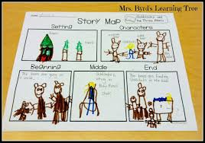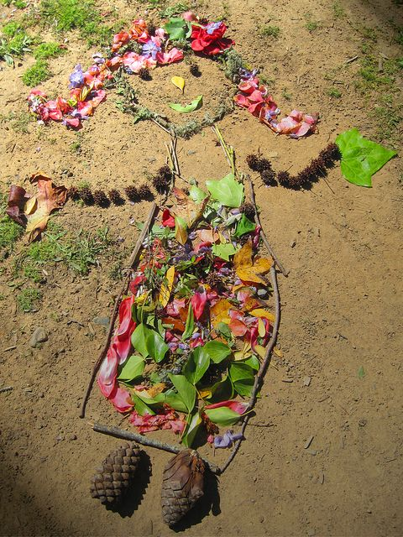  Make a picture from things you find in your garden on a walk around your local area, then make up a story about what you have made ( you could video it or write in down with adult help)
Learning Project - to be done throughout the week
The project this week aims to provide opportunities for your child to learn more about the area in which they live. Learning may focus on your local area, famous people, key landmarks and links to your city. There are some great resources on Twinkl for houses and homes as well as the local area.
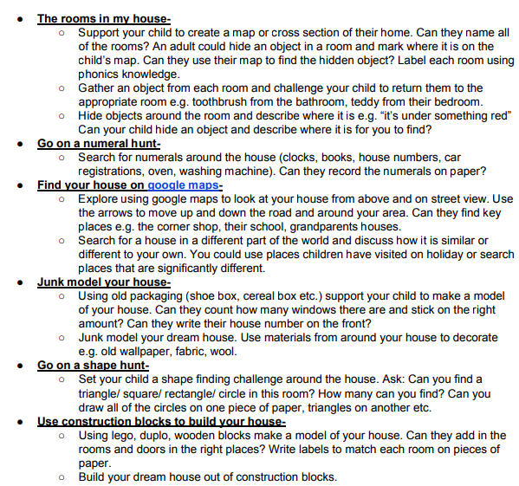
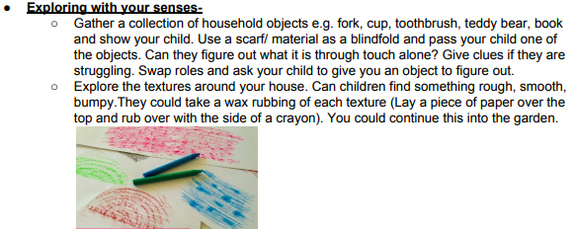
- Create a song about ‘Where you live’ - Listening to this one might help. Can you add your address in your song?
- Can you find your house on the map? Can you see Higham’s Park station? What places have you visited?

Additional learning resources parents may wish to engage with
Waltham Forest have collected plenty of useful resources to keep you and your children entertained during this time.
Thanks to #TheLearningProjects who let us use their learning materials for you at home

