Nursery Home Learning project
Week 7 and 8
Toys
Here are a few suggestions for activities that relate to our topic for the next few weeks. Pick activities which you feel your child will most engage with and don’t feel you have to do all of them, they are here as a guide. You might find other things that work really well so go for it.
Remember play is the most effective way children learn at this stage
Daily tasks
Establishing a daily routine will help so here is a rough guide
Read the morning message from Miss Walter
Watch a video from Miss Walter then have a go at the task
Free play or pick an activity from the list below
Watch a story video
Upload something onto the homework page to show us what you have done

Maths Activities | English Activities
Counting and recognising numbers  There will be two Number videos on the website this week  Have a look at the Homework prompts from the week beginning 8.2.21 for more activities if you haven’t already done them  Maths activities for toys  Number-Count toys for picnic – share plates/cups etc, role play food.  Set up a toy shop  Match toys to numbers  Order toys by height, draw large and small teddy bears,  Shape -Can you find shapes on your toys? What shape is your teddy’s nose etc  Create pictures of toys using shapes  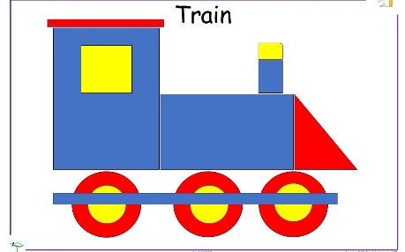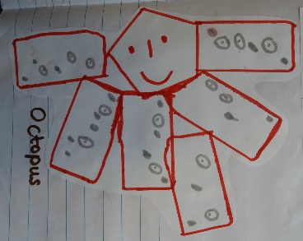  Positional Language – play hide and seek with toys and ask children to find the toy. Ask children to put the bear behind the chair/under the chair/in front of the chair  Play number games  This is a great website we often use at Handsworth. Select Early Years to get age-appropriate games for Nursery  https://www.topmarks.co.uk/  Numberblocks  Watch a programme on CBeebies  Singing  Sing number songs to practice counting, reciting numbers in order, one more, one less. Click on the link below to get started  https://www.bbc.co.uk/teach/school-radio/nursery-rhymes-ten-in-the-bed/z7bnmfr  Here are some more great counting songs that we like singing in Nursery  https://www.youtube.com/watch?v=7D4K9oi7oBM  These activities are ones we would do in Nursery and worth repeating as many times as you can. | Phonics  There will be two Phonics videos on the website this week  Watch this video to make sure you are saying the sounds correctly.  https://www.youtube.com/watch?v=UCI2mu7URBc&feature=emb_logo  It is more important that children can hear this weeks sounds at the beginning of words than learning to write them. Please don’t worry too much about teaching the letter formation, it is there as a guide if the children are ready for it.  Spoken segmenting and blending  This is a great way to emphasis the separate sounds in words. Blending and segmenting is a later skill that will be important when the time comes for your child to read and write.  Ask children to go and get their h-a-t or b-a-g have a go with simple 3 letter words but move on to bigger words if you can!  Phonics games  I spy names-Sit in a circle and play ‘I spy names’. “I spy someone’s name beginning with ‘s’. Who can it be”  The person with the name beginning with ‘s’ stands up and all the children say his name. You can use toys if you don’t have lots of people in your house  Object sound game  Find objects around the house that begin with the same letter. Can you make up an alliterative sentence with all the objects?  Alphablocks  Watch a clip on CBeebies  Some children may not be ready for these activities so it is ok to repeat any of the activities above.  - Give children lined paper and pens/pencils so they can ‘write’ a story of a letter or a list. It could be anything. Encourage them to tell you about their writing when they have finished.  (if you don’t have any lined paper we can give you some writing books from school. I will leave a selection of books in the school office)  - Give children a selection of pens/pencils for writing or drawing. Ask them to tell you what they have drawn and annotate it like it was a picture in a museum. If your child is into dinosaurs this is a great way to link their interest with writing!  Some other tools and resources to enable writing  - Blank diaries and calendars  - Telephone and address books  - Post-it notes  - Envelopes  - Postcards  - Invitations  - Chalk -can be used inside on a blackboard or outside on paths etc  - Sticks and twigs with earth/mud  - Clipboards and paper  - Pens/pencils/crayons/chalk  - Stampers with ink pads  - Paint brushes and paint or water  Read with your children daily.  Let them be in charge of which books they would like to read. For online books visit Oxford Owl for free eBooks that link to your child’s reading stage if they are ready for this. These books also have audio and so your child can listen to the story being read whilst following along with the words. You can create a free account by clicking on the link below. You can also complete the linked play activities for each book afterwards.
Physical development  Play outside in the garden/go to the park or forest  Pick a cosmic kids yoga story to try  Make playdough, click here for a recipe  Have a go at these playdough gym activities  Cook dinner!  We like cooking recipes from CBeebies My world kitchen  https://www.bbc.co.uk/cbeebies/shows/my-world-kitchen  Each Monday there will be a new Finger gym activity to try on the website | Art  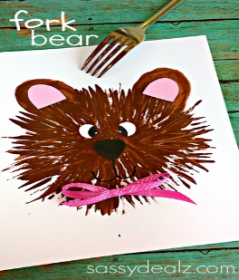.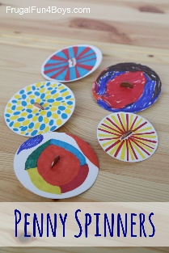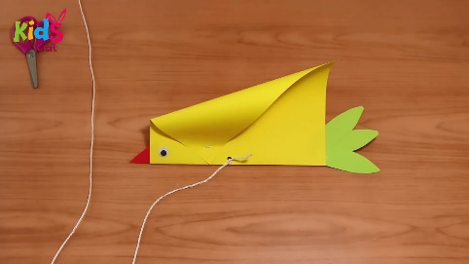  Make a spinner  https://frugalfun4boys.com/penny-spinners-tops-kids-can-make/  Make toys from paper  https://sugarspiceandglitter.com/homemade-paper-toy-crafts/  Make stick puppets and have a puppet show  Make a paper bird kite  https://www.youtube.com/watch?v=mKN0RzxNQhQ  The internet is full of other great ides!
Science/Understanding the world  Everyday activities that could include predictions could include cooking, gardening, having a bath or washing up  Science experiments  Here are a few websites that have great ideas for simple Science experiments.  - https://www.firstdiscoverers.co.uk/early-years-science-activities-eyfs/  - https://www.science-sparks.com/early-years-science-themed-activities/  - https://www.stem.org.uk/resources/community/resource/258613/early-yearsreception-science-homeworks  Can you build a place for your toys to live. You could use bricks of you have them or boxes. You could even go outside and use things from the garden  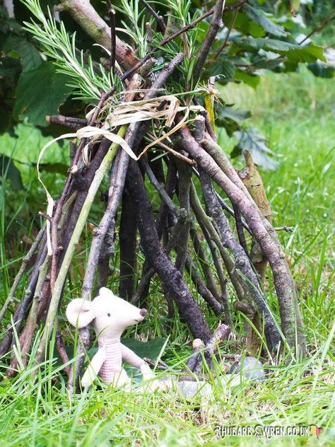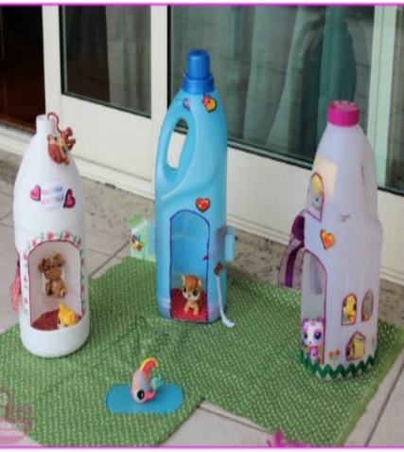  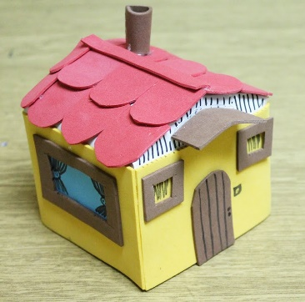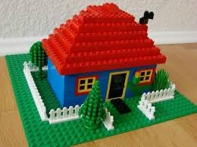 | Website  There will be a daily homework prompt on the website so you can upload pictures or videos of anything you do as well as daily videos and activities  Look in Archive/Articles 2019/20 for some great activities from Mrs Giacuzzo and Mrs Lewis  Check out this great website which has the whole day planned for you and uses minimal resources where possible  https://www.eyfshome.com/activities
Additional resources
There are some great websites to look at in the Home Learning section of the Nursery webpage

Keep Early Years Unique
online activities or suggestions of things to do that don't require the use of tech
https://www.keyu.co.uk/new-learning-at-home-together/

National Geographic Kids
https://www.natgeokids.com/uk/
Activities and quizzes for younger kids.

Nature Detectives
https://naturedetectives.woodlandtrust.org.uk/naturedetectives/
A lot of these can be done in a garden, or if you can get to a remote forest location!

