Reception Newsletter

Summer Term 1
2017
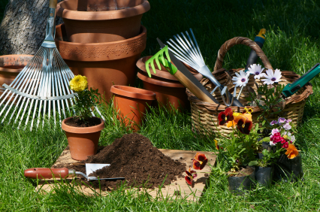

Our topic this half term is: Spectacular Sprouting

Welcome back! We hope you had a great Easter holiday. It was lovely to see the children again and hear all their exciting news.

Literacy
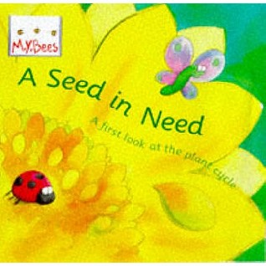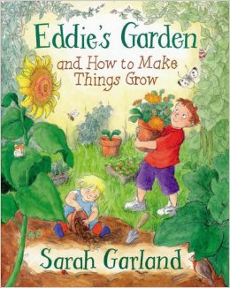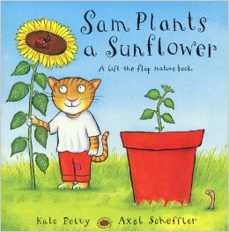

This term we will be focusing our literacy work on ‘A Seed in Need’ by Sam Godwin, ‘Eddie’s Garden’ by Sarah Garland and ‘Sam Plants a Sunflower’ by Kate Petty. The children’s writing skills have really developed and so we will be writing for lots of different purposes, such as labels, lists, descriptions, speech bubbles, captions and story writing. We will be reading lots of fiction and non-fiction books that link in with our topic.

Our Author Focus this term is Eric Carle and we will be reading lots of his books and discussing our favourites. Let us know what your favourite one is and we will try and read it.

We would like to make a class information area about growing and planting with books, pictures, photos of your gardens or allotments and any interesting artefacts, such as dibbers or other gardening equipment. If you would be willing to let us borrow any of these please send them in and we promise to take good care of them!

Reading Book, Key Words and Phonics
The children continue to make excellent progress with their reading and are segmenting and blending brilliantly. We will be learning more digraphs and trigraphs and will now be looking at different ways to make the same sound, such as ‘air’ (hair) and ‘are’ (care). Watch out for the split digraphs too. We will let the children explain to you what these are!!!

Please remember to send the books in everyday and don’t forget to sign the yellow record book otherwise books cannot be changed (we recommend that the children read their reading book at least 3 times a week).

Well done for practising your key words at home. We will shortly be sending home the last set of key words. It is important that these are practised as often as possible. Why not try writing them in sentences and sending them to school to share with the class.

Maths
In Mathematics the children will be continuing to develop and consolidate number work, counting, ordering recognising and recording numbers to 20 and beyond. We will continue to explore addition and subtraction, looking at a range of strategies, and number bonds to 20, as well as practising doubling, halving and sharing in lots of practical and everyday situations. When you next cut up your potatoes or apples, why not share them out! When out shopping, can your child recognise the coins that you will need. To link in with our topic, we will be measuring objects and gathering data to use in problem solving activities.

PE
The PE times have stayed the same for both classes. In the Summer term we do as much PE as possible outside and it is therefore really important that the children have the correct PE kit in school. Please ensure that all items are clearly labelled and in their PE bag.

Attendance and punctuality.
At Handsworth Primary School we pride ourselves on excellent attendance and punctuality. Please remember that school starts promptly at 8.50 and finishes at 3.30.

News
We would like to do as much planting of real plants and seeds as possible. If you have any spare plants, plant pots or old tools that you want to get rid of, we would love to plant them in our growing area.

In the last half term there will be a school trip. More details to follow.

Help!
Our jigsaw puzzles are looking rather sad and depleted. If you are having a clear out and you think we could use your old jigsaws please send them in as they would be much appreciated.

We are in URGENT need of spare underwear. If you have any that your child has out grown we will gladly take them off your hands.

As the weather heats up over the next term, please ensure that your child has a sun hat to wear for outdoor play and that any sun cream has been applied before school. Hats must be clearly labelled with your child’s full name.

Thank you
Reception Team.

