1. **Column addition with and without exchange. Due 20/11/20**

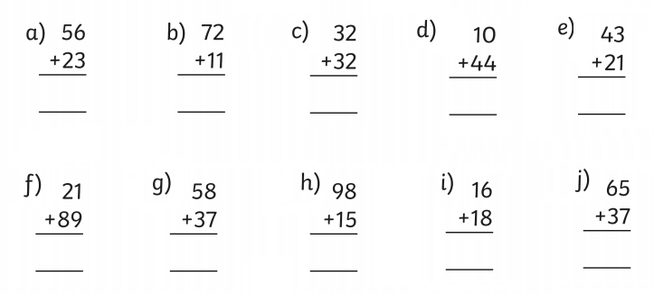

1. **Use column addition to solve these problems.**



1. Ed and Amir are collecting Lego cards. Ed has collected 43 and Amir has collected 51. How many cards do they have altogether?
2. Aiko and Anya are playing a game. Aiko scores 36 points and Anya scores 57 points. How many points have they scored altogether.
3. Naz and Advick are playing a game. Naz scores 15 points. Advick scores double that amount. How many points did they score altogether?

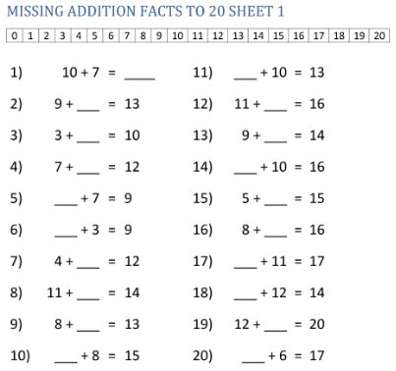

**Knowing and having a quick recall of your addition facts to 20 is vital to ensure we don’t get stuck in our column addition and subtraction methods!**

**Remember! Practice makes perfect!**

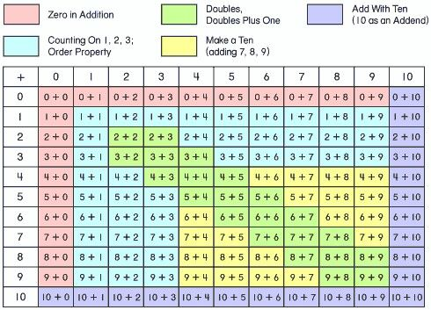

Quiz me!!!