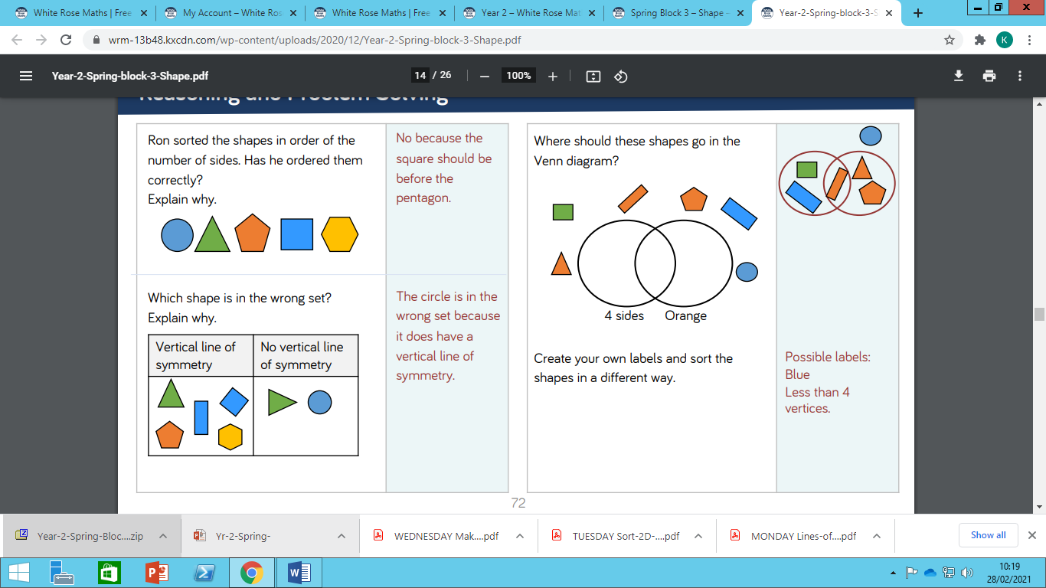

Tuesday Maths Challenge Questions