How to Make Butter In a Jar
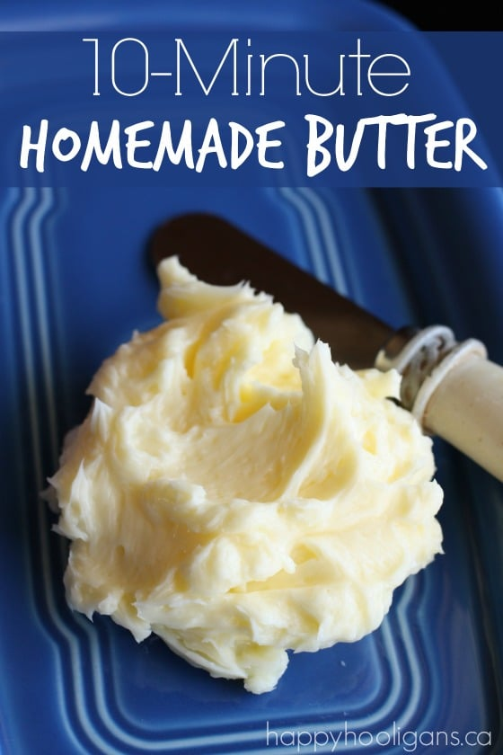
Making your own butter couldn’t be easier! It’s so easy. All you need is some cream and a glass jar! Oh, and a little elbow grease. That’s the fun part. You’re going to shake, shake, shake your way to your batch of tasty homemade butter, and that does require a bit of muscle. You can do it though!

To Make Homemade Butter, You’ll Need:

- a glass jar with a lid
- heavy cream (35% whipping cream)
- 2 or 3 glass marbles (optional)
Please note that the marbles are optional. You do not need to us them but some people say it speeds up the process because they provide extra agitation for the cream. If you use the marbles, make sure your glass jar is made from thick tempered glass. You wouldn’t want the marbles to break the glass.

How to Make Homemade Butter in a Jar
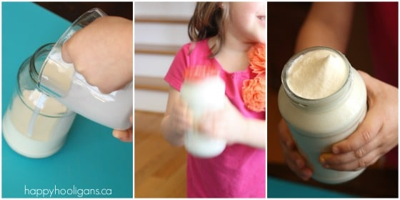
Step One: Fill your jar half way with cream. If you’re using marbles to speed up the process, drop them in now.
Step Two: Put the lid on tightly and SHAKE it like crazy!
After a minute or two, the cream will thicken, and you won’t hear liquid sloshing around anymore.

As the Cream thickens, you get Whipped Cream!
About halfway through, take the lid off to see what’s happening inside the jar. The cream has turned into whipped cream! You can grab a spoon, and taste some.
Pop the lid back on, and keep shaking. After a few more minutes, you’ll hear liquid sloshing around in the jar again. Buttermilk!

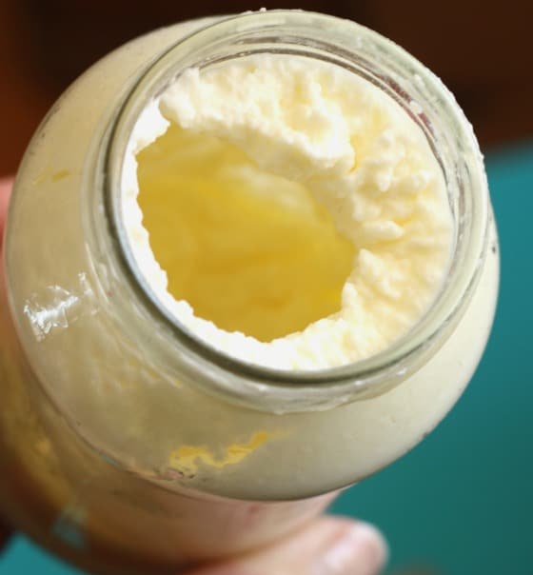
If you peak inside, you will see that the sloshing is the buttermilk separating from the butter that’s starting to solidify in the jar.
Almost ready!

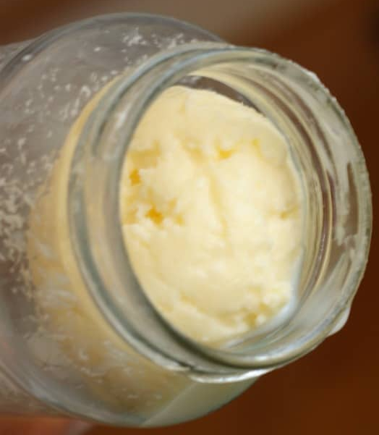
Once again, pop the lid back on, and shake it for another minute or so, until the butter has formed a solid mass.

We made BUTTER!
Pour off the buttermilk and shake the butter out of the jar.
So…
What is the science behind making butter?
When shaking the fresh cream, the fat molecules in the cream get shaken out of position and clump together. Eventually, after enough agitation, the fat molecules that are clumped so much forms butter. During this process, the fat molecules gets separated from the liquid in the cream, and this liquid is called buttermilk and can be removed.

Now is your turn to think.

Can you turn butter into cream?

Let us know by emailing your explanation and, of course, some of your lovely photos from your experiment.

