Hello Year 6,
Please find below a number of learning activities and extensions that you can do at home. Feel free to choose the ones that suit you best and attempt as many as you would like to. You can then bring them into class when finished and share them with the rest of your class and year group - inspiring others to do the same.
If you have any questions or would like support, please ask your teacher.

1 - Planning and teaching a lesson.
We would be delighted to offer you the chance to teach a lesson to your class. Make sure you discuss with your teacher before you plan to ensure the lesson is relevant and can fit into the timetable. If you are able to teach a lesson based on current learning or topics that would be fantastic.

2 – Help the Poet Tree grow.
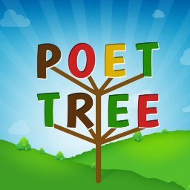
We have a wonderful Poet Tree in the Year 6 corridor that we look forward to seeing grow throughout the year. You can write a poem to add to the tree, taking great pride in knowing it will be on display for all to enjoy.

3 - Write a newspaper report.
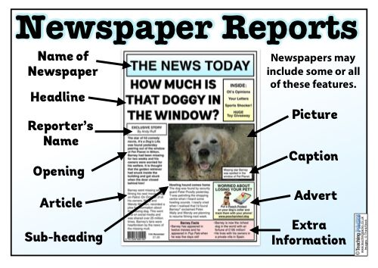
We have reviewed the features of a newspaper already this year and written some fantastic reports already. Can you write a newspaper report about something that you have seen or experienced? It could be a competition, a performance, an event or it could be a particular day or moment that you enjoyed.

4 - Create a dance routine.
We are currently doing Dance in PE so you could create your own dance routine. You may like to present this in the form of a power point or a step by step instruction format. You could also video yourself teaching it or decide to teach it in your PE lesson.

5 - Carry out and write up a Science experiment.
Follow these links for some ideas of experiments you may be able to do at home.
http://www.sciencefun.org/kidszone/experiments/
https://mommypoppins.com/kids/50-easy-science-experiments-for-kids-fun-educational-activities-using-household-stuff
https://redtri.com/classic-science-experiments/slide/6
Have a look through these with an adult and see what experiments you could do in your own home! Make sure you ask for permission first.

When writing up the experiment, remember to use the following Sub Headings: Introduction, Equipment, Variables, Prediction, Method, Results, Conclusion.

6 – A presentation of data.
You could survey people about something you are interested in and produce the results in a number of ways (bar charts, pie charts, scatter graphs, tables etc). After this you could use your results to provide a thorough analysis and conclusion. Maybe it could be to do with a role that you have at school?
7 - Ancient Greeks
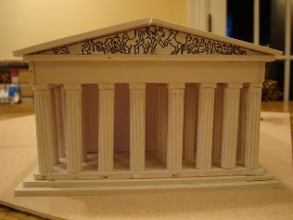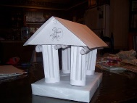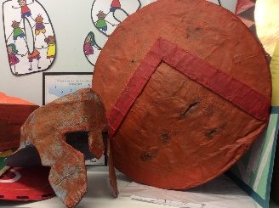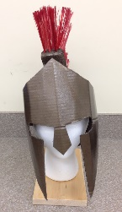
Later this term we will be concentrating on Ancient Greece for our History topic. You could make some or all of your costume ready for Wow Day. It could be a helmet, a wreath or a shield. Another thing you could do is imagine you are an architect in Ancient Greek times and you are designing your own building. You can then make this.
There will be more Ancient Greek activities to come later in the term...

8 - Research a country from South America.
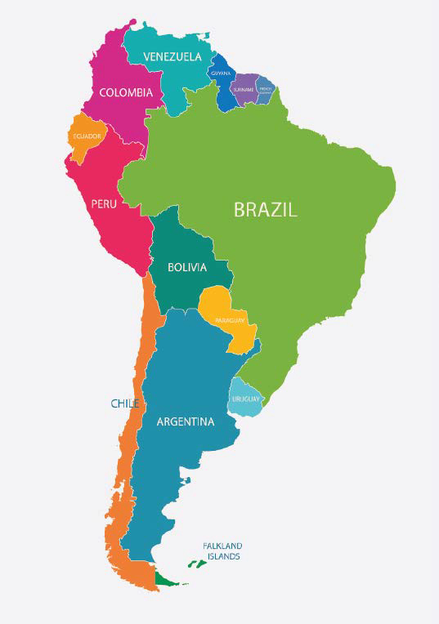
Find out about where the country is, its capital city, what food they grow, what the climate is, landmarks the country has, moments the country is famous for, sports the country plays, religion, culture and tradition, any famous people from the country. You can present this in any way that you would like and we can use it in our Geography lessons this term.

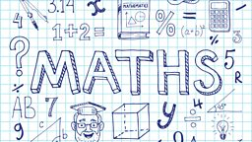

Maths extension activities – If you haven’t already have a look at this website for hundreds of games and challenges https://nrich.maths.org/primary
If you would like more Maths challenge please ask your teacher and we will provide you with further revision or extensions.

