Nursery Home Learning project

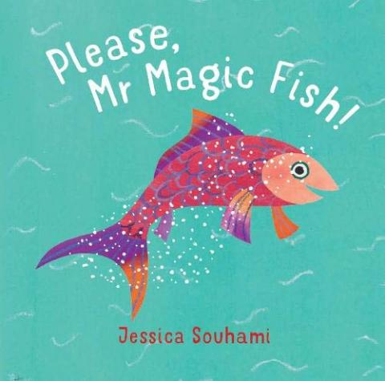

Activities are based on Please Mr Magic Fish by Jessica Souhami
Click on the picture to hear the story

Here are a few suggestions for activities that relate to our topic for the next 10 days. Pick activities which you feel your child will most engage with and don’t feel you have to do all of them, they are here as a guide. You might find other things that work really well so go for it.
Remember play is the most effective way children learn at this stage

Daily tasks
Establishing a daily routine will help so here is a rough guide
Focused Maths or English task
Free play or pick an activity from the list below
Snack/lunch (a great time to practise Fine motor skills such as chopping!)
Watch a story video - there will be one posted every afternoon
(the videos from Lockdown are also available on the Nursery Home page)
Email Miss Walter with a picture of something you have done each day
Maths Activities | English Activities
Number formation  Click here for the rhymes we will use to help Number formation Don’t worry about pencil grip at this stage as it is a work in progress!  Number  Scan the QR code below to watch a Maths lesson. There are 5 sessions with accompanying pdf’s  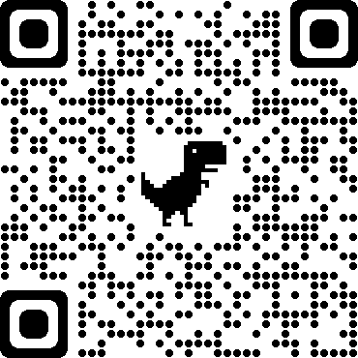  Addition  Click here to download Numicon shapes. These can be cut out and then put together to make a bigger number  Numicon.pdf  Click on the link below for some more ideas about addition  https://www.teachstarter.com/gb/blog/10-easy-simple-addition-activities-kids-gb/  Numberblocks  Watch a programme on CBeebies, Use this guide here to give you ideas on what to do with your children whilst watching an episode.  Singing  Sing number songs to practice counting, reciting numbers in order, one more, one less. Click on the link below to get started  https://www.youtube.com/watch?v=V_lgJgBbqWE  Make a timetable of your day- children like to know what is happening and when. A timetable is also a great way to introduce the concept of time  Play ‘Watertown’ with different sized containers ( watertown is the Nursery game of playing with water and using lots of different containers to pour and move water around!) | Phonics  Here are some Phase 2 games to try. We have only just started learning letter sounds, many games offer the option of selecting or editing the sounds used in the game so it can be made easier or harder to play  Alphablocks  Watch a clip on CBeebies  Use this guide here to give you ideas on what to do with your children whilst watching an episode.  Letter Formation- Can you trace/write the letters in your name? Do you know the sound that each letter makes? Don’t worry about pencil grip at this stage, it is a work in progress!  Reading  - Everyday there will be a story on the Nursery page to watch  - Look at the books you have at home which ones are your favourites?  - Do you have stories from different countries? Can you find those countries on a map of the world?  - Perhaps your family could share their favourite stories with you  - What if the story took place near woodland? What kind of character would grant wishes there?  Read with your children daily.  Let them be in charge of which books they would like to read. For online books visit Oxford Owl for free eBooks that link to your child’s reading stage if they are ready for this. These books also have audio and so your child can listen to the story being read whilst following along with the words. You can create a free account by clicking on the link below. You can also complete the linked play activities for each book afterwards.  https://www.oxfordowl.co.uk/please-log-in?open_loginbox=true  Draw a picture of what you did today.  Write down what your child tells you about their picture. Read the words back to them pointing to each word as you read. This will reinforce the idea that in English we read from left to right  Writing  Print out pictures of favourite story characters and encourage your child to either write about the character or dictate a story to you that you then read back to them. This writing may look less like recognisable letters and more like random marks but it is important to acknowledge it as ‘writing’  Take photos of activities you do and write a caption to describe what is happening in the photo  Read poems about being outdoors ‘Out and about’ by Shirley Hughes is a great place to start
Physical development  Gross Motor (whole body)  - Play outside in the garden/go to the park or forest  - Pick a cosmic kids yoga story to try  - Do a daily workout with Joe Wicks  - We like making costumes out of fabric in Nursery. Make a costumes out of scarves or clothes from the grown ups at home and act like a fish swimming away or a fisherman swishing a net  Fine Motor( small hand/wrist movements)  - Building a tower of approximately nine small blocks.  - Copying block designs of up to 9 blocks.  - Designing own Duplo/Lego models  - Tracing on thick lines  - Copying a simple shape such as a triangle or circle  - Colouring a picture  - Writing letters/numbers  - Writing their name  - Threading a sequence of small beads onto string.  - Cutting roughly around pictures/cutting along a line continuously  - Dressing independently including large buttons, socks and shoes (excluding shoelaces, small buttons and initiating zip on a jacket).  Make puppets to act out the story  Paint pictures and make models (see Art activities)  Make playdough, click here for a recipe | Art  - Make a model of a house using junk modelling objects – will your house be like a castle or a spaceship? Will it be tiny or will it be enormous?  - Paint or draw a Magic fish click here to make a Japanese kite fish for your garden or balcony  - Can you paint a picture of the sea by making lots of different shades of blue  - Look at famous paintings of the sea at The National Gallery which ones do you like?
Topic activities  - Look at the different houses that belong to Jack and Liz throughout the story and explore different houses and homes more widely. What kind of home do the children live in?  - Children could draw or paint their house or the house of people in their family  - Challenge the perception that everyone lives in a house like yours by reading picture books that represent living in a flat positively, such as:  Alphonse, There’s Mud on the Ceiling! Daisy Hirst (Walker  Lulu Loves Flowers, Anna McQuinn and Rosalind Beardshaw (Alanna Max)  Oscar’s Half Birthday, Bob Graham (Walker)  Errol’s Garden, Gillian Hibbs (Child’s Play)  The Seeds of Friendship, Michael Foreman (Walker)  - Click here to see different types of houses  - Find out about different types of fish. What is the strangest fish you can find?  - Where in the world would you find these fish living? Where do you think a magic fish would live? | - Use things from your toy box, cupboard or wardrobe to act out parts of the story.  - Practise singing some of the Nursery rhymes we have learnt. There will be some more to learn on the Nursery website
Personal, Social and Emotional activities
Practise one of the breaths we have learnt as often as needed
Read The Colour Monster book by Ana Lenas or listen to Miss Walter reading the story on the Nursery website (6.10.20) and spend time talking about the feelings described in the story. It’s a great book to use regularly to help discuss emotions and what helps us when we feel sad etc
Print out the Colour Monster pictures to refer to as needed
Keep a gratitude jar in which children can place notes of appreciation for things others have done to make them feel thankful. Or something they are glad about that has happened that day.
What are your dreams and wishes? If you met a magic fish what wishes would you make?

