Homework to be completed: Due 27/11/20
Task 1
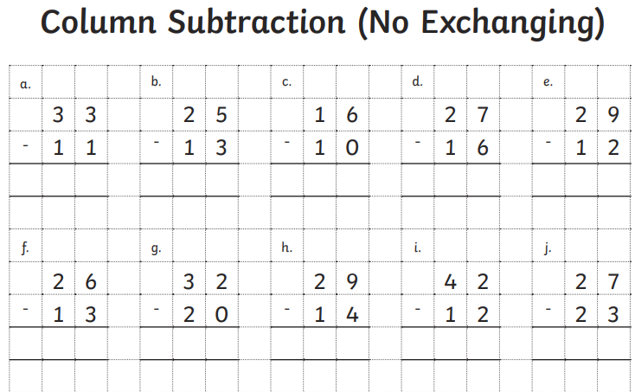
Task 2
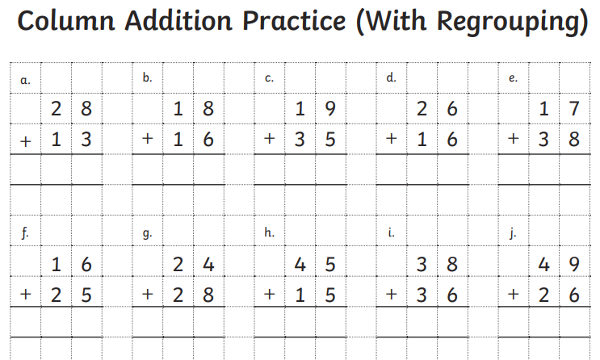
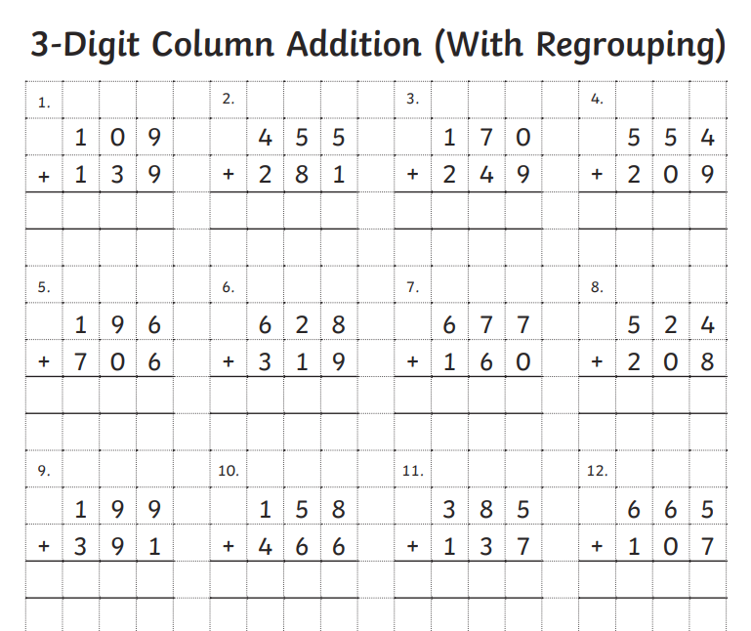
Optional Challenge

Word Problems:
- Aisha and Lara are playing a game.
Aisha scores 234 points. Lara scores 159 more than Aisha.
How many points do they score altogether?

- Emir and Matt are playing a game.
Emir scores 267. Matt scores double this amount.
How many points do they score altogether?

