HOW TO MAKE A HOMEMADE VOLCANO?

Making your own homemade volcano is really simple and requires basic material that you can find around the home.

WHAT YOU WILL NEED?
You will need an empty plastic bottle (this is 1 litre bottle), newspaper torn up in strips, PVA craft glue, masking tape and a container for the water and glue mixture.
To make the lava to mimic that of a real volcano you will need bicarbonate soda, red and yellow food colouring (or orange) and white vinegar.
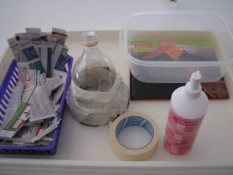

Instructions:

To make the basic shape of a volcano, cut the middle of the plastic bottle out and then overlap the two ends together securing it with masking tape.

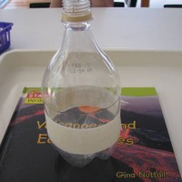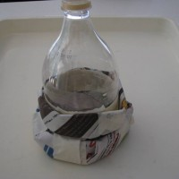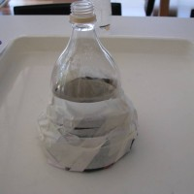
To give the volcano a more pyramid/mountain shape roll a newspaper into a tube shape and wrap it around the base of the plastic bottle, securing it all with masking tape.

Time to get messy: Apply Paper Mache to your volcano using small strips of newspaper dipped into a gluey water mixture. Fold a small amount of newspaper into the opening of the bottle but making sure there is enough room to add your bicarbonate soda and vinegar later.
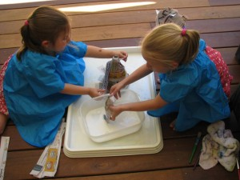
Tip – keep some old flannels or cloths handy to wipe your hands on.
Let the Paper Mache to get dry, It would be great to watch a few videos on You Tube about volcanos while you are waiting for the Paper Mache to dry.
Paint your volcano.
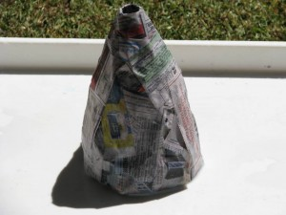
Again while you are waiting for the paint to dry have a practise run to see how much bicarbonate soda and vinegar would be needed for the homemade volcano. To give you a bit of an idea, 4 tablespoons of bicarbonate soda and 1 cup of vinegar mixed with some red and yellow food dye and this seemed to Sift the bicarbonate soda into the funnel and pour in the vinegar…..you have to be super quick to get the funnel out.
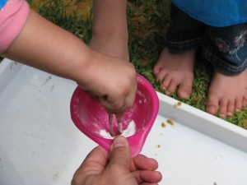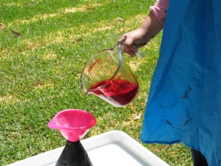
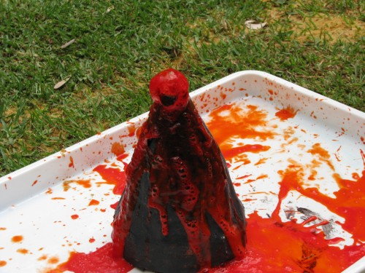
Enjoy your homemade volcano fizzing and frothing as the bicarbonate soda and vinegar react together. You can repeat the eruption as many times as you like!

SOME SIMPLE FACTS ABOUT VOLCANOES:
- A volcano is a mountain that erupts.
- Rock under the earth’s surface is so hot that it melts. This melted rock is called magma.
- Erupting magma is called lava.
- Volcanoes become bigger every time they erupt as the lava cools and makes a new layer of rock.
- Volcanoes can erupt under water and form new islands from the cooled lava.
- Volcanoes can be found on the moon and other planets.
- There are more than 500 active volcanoes on Earth.
MAKE IT AN EXPERIMENT
The project above is a DEMONSTRATION. To make it a true experiment, you can try to answer these questions:
1. Does vinegar temperature affect how fast the volcano erupts?
3. What can be added to the “lava” to slow it down and make it more like real lava?
4. What combination of vinegar and baking soda creates the biggest eruption?

