Famous People Project/WOW Day

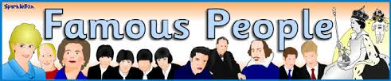

As part of our half term topic, the children will work on a project as their homework for the next few weeks in preparation for our Famous people WOW Day on Thursday 21st May (children to dress up as a famous person).
The children can choose a famous person that they are interested in and prepare a presentation to show their year 2 classmates. They can present their work in any form e.g. posters, books, PowerPoint, artwork etc.
We are sure the children will enjoy working on this project as they did for the ‘Around the World’ Project and we look forward to seeing your creative costumes and projects.

