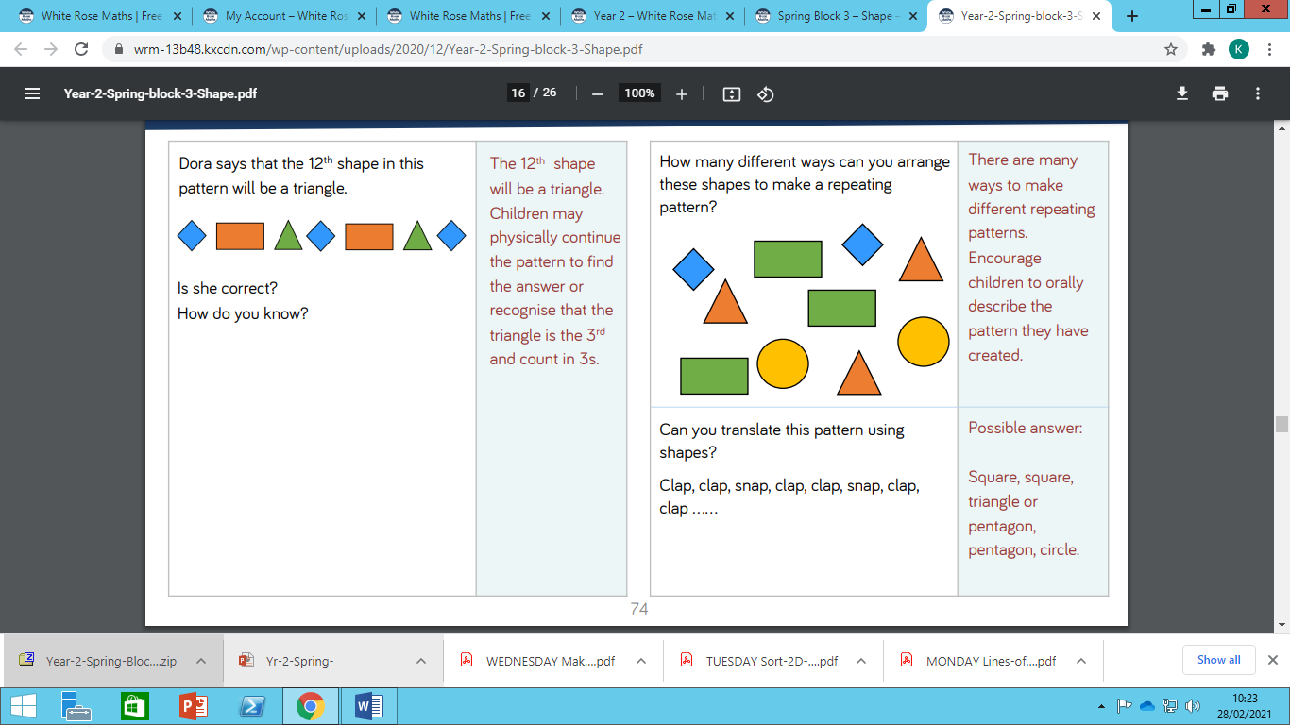

Wednesday Maths Challenge Questions