Animal Project/WOW Day

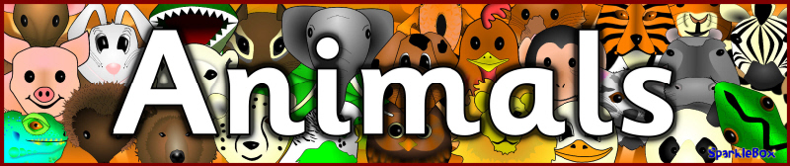
Dear parents/carers,
As part of our half term topic, the children will work on a project as their homework for the next few weeks in preparation for our Animal WOW Day on Friday 24th June (children can dress up as an animal).
The children can choose their favourite animal that they are interested in and prepare a presentation to show their year 1 classmates. They can present their work in any form e.g. posters, books, PowerPoint, artwork etc.
The children have worked so hard on their “Space” and “Growing” Projects and we produced some fantastic pieces of work.
We look forward to seeing their creative costumes and projects on Friday 24th June.
Many thanks,
Year 1 team.

